Revenue Strategy Dashboard
Module 5

Overview
The Revenue Strategy Dashboard provides a comprehensive analysis of hotel revenue streams across various service categories including Dining, Services, and Spa. This module not only highlights revenue insights and booking trends but also incorporates dynamic pricing intelligence using adjustable parameters such as Price Uplift % and Occupancy Sensitivity.
The purpose of this dashboard is to assist Revenue Managers in optimizing pricing strategies, identifying profitable service lines, and adjusting pricing based on market demand and occupancy levels.

1️.Visual: Sum of Amount by Year, Month & Service Type (Clustered Column Chart)

Purpose
This visual shows seasonal and yearly revenue trends across different service categories (Dining, Services, Spa). It helps identify peak months, slow periods, and long-term revenue patterns.

Measure Used
TotalRevenue =
SUM(HotelBookings[Amount])

Filters/Breakdown
- Axis: Month
- Legend: ServiceType
- Filter: Year Selector

Analysis Insight
This visual helps revenue managers plan promotions, staffing, and resource allocation based on high and low-demand months.
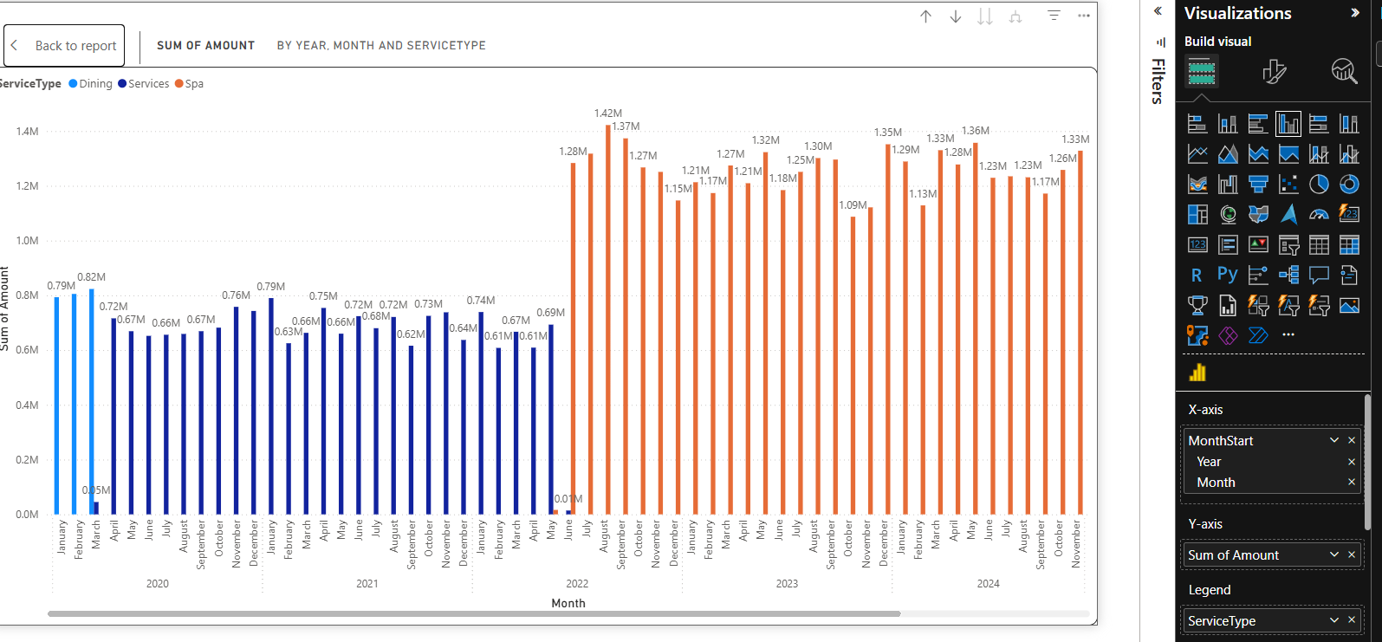

2️.Visual: Sum of Amount by Service Type (Pie Chart)

Purpose
This chart shows the percentage contribution of each service category to total revenue.

Measure Used
Revenue by ServiceType =
CALCULATE(
[TotalRevenue],
ALLEXCEPT(HotelBookings, HotelBookings[ServiceType]))

Insight
Helps identify the most profitable service type and understand shifts in consumer spending behavior.
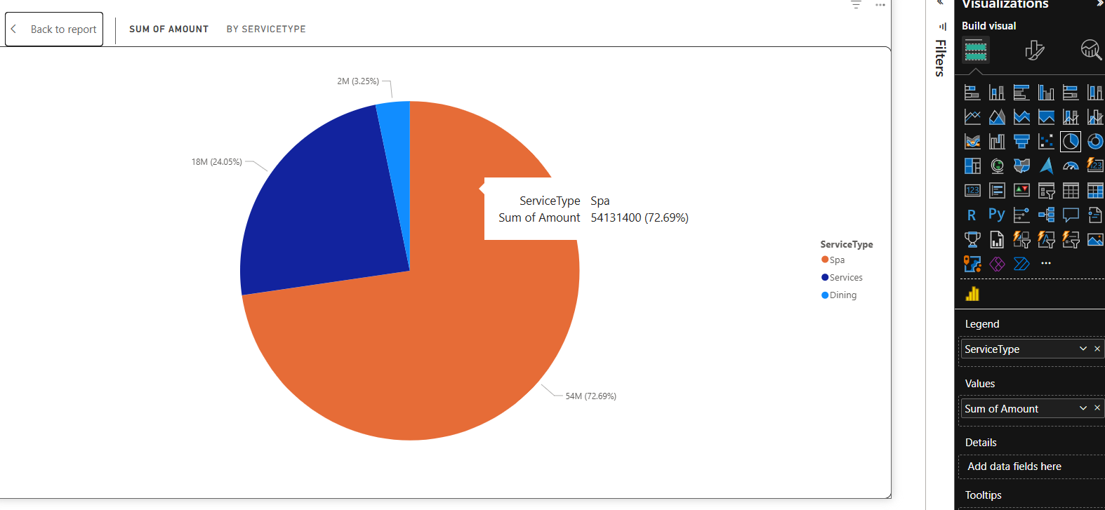

3️.Visual: Revenue & Booking Count Matrix by Year and Service Type

Purpose
Displays yearly financial and operational performance for each service type.

Measures Used
Revenue by Year =
CALCULATE(
[TotalRevenue],
VALUES(HotelBookings[Year])
)
BookingCount =
COUNTROWS(HotelBookings)

Insight
Helps budget planning and year-over-year comparison to detect growth opportunities or performance drops.
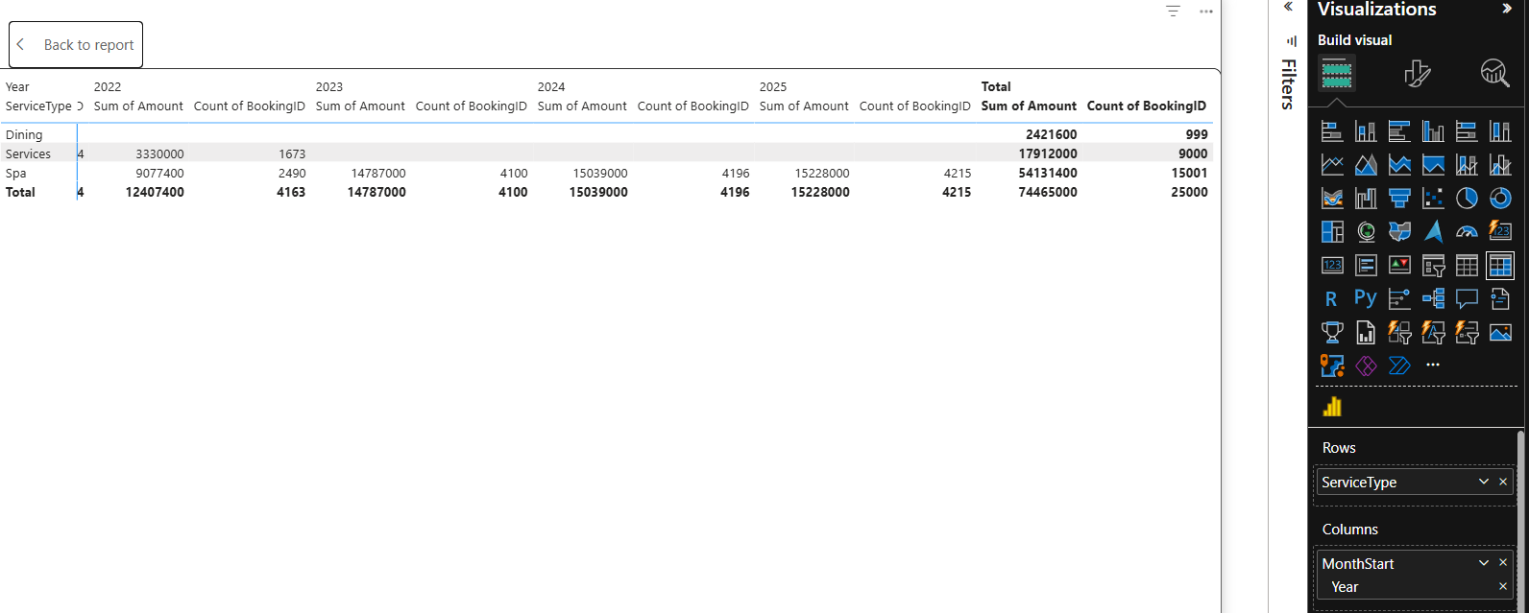

4️.Visual: Pricing Tier Recommendation (Table)

Purpose
Suggests optimized pricing per room type based on occupancy levels and price sensitivity settings.

Key Measures Used
Price uplift input (what-if parameter)
PriceUplift% = SELECTEDVALUE(PriceUplift[PriceUplift])
Occupancy sensitivity input
OccupancySensitivity =
SELECTEDVALUE(OccupancySensitivity[Value])
Occupancy-based price adjustment
RecommendedPriceAdjustment =
[PriceUplift%] * [OccupancyRate] * [OccupancySensitivity]
Recommended Final Price
RecommendedPrice =
[BasePrice] * (1 + [RecommendedPriceAdjustment])

Insight
Supports revenue optimization without manually recalculating price tiers.
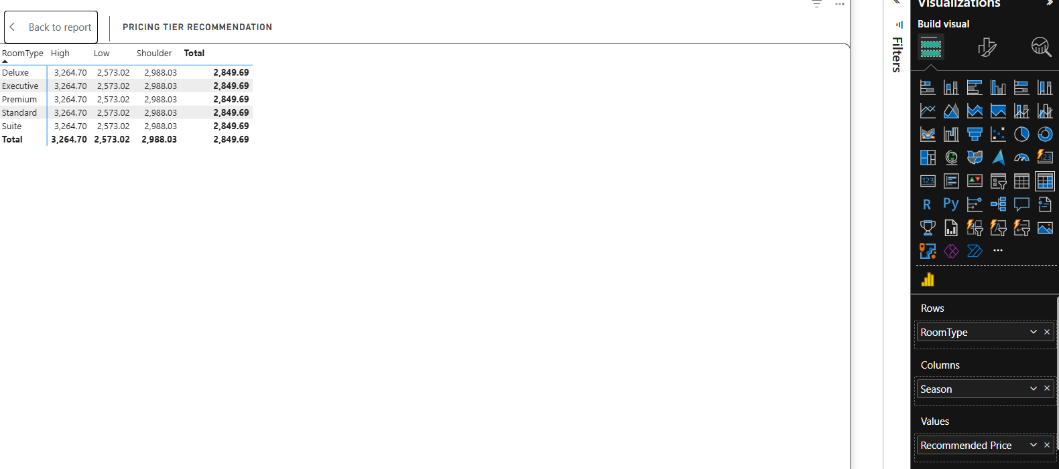

5️.Visual: Price Uplift % (Slider Control)

Purpose
Allows simulation of how pricing changes would affect revenue strategy.

Field Used
Created via What-If Parameter.
PriceUplift% = SELECTEDVALUE(PriceUplift[PriceUplift])

Insight
Helps test pricing strategies such as festival hikes, seasonal premium pricing, or discounting.

6️.Visual: Occupancy Sensitivity Slider

Purpose
Adjusts how sensitive the pricing model is to occupancy levels.

Field Used
OccupancySensitivity =
SELECTEDVALUE(OccupancySensitivity[Value])

Insight
Allows scenario modeling — aggressive dynamic pricing vs. safe pricing approach.
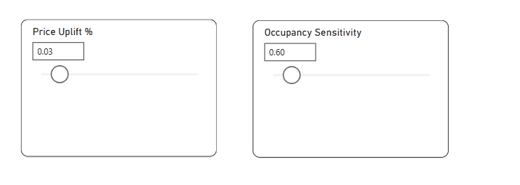
GENERAL MANAGER DASHBOARD
